Unity – Tower Defence

In this tutorial we will create a simple Tower Defence game using waypoints to guide the enemy along a pre-set path. For the defence a basic turret will be created that will track enemy within a given range and shoot constantly until the enemy is destroyed or out with the given range of the turret.

# Unity Version 2019.2.5f1

# Setting up the Project

1. Use unity hub or open Unity 2019.2.5f1 directly.
2. Click the **New** button to create a new project.
3. Choose the 3D template.
4. Name the project **TowerDefence**. (NOTE there are no spaces)
5. Make sure you have your projects Location set your own personal unity projects folder. (i.e. Desktop/YOURNAME/Unity Projects/ )
6. Click the **Create** button.
7. Save the current scene with ‘*Ctrl + S’* or ‘*File > Save’*. Rename the **SampleScene** in the ‘Scenes’ folder and rename it **Level1**.
8. A prompt informing of changes to open scene will appear, left-click the **Reload** button to reload the scene with the updated name.

# Setting up GitHub Repository

1. Open GitHub Desktop.
2. Use keyboard shortcut **CTRL + N** to create a new repository.
3. Name the project the exact same as your unity project **TowerDefence**.
4. Add a small description of your game, (i.e. Tower Defence game developed with Unity)
5. Set local path to YOUR **Unity Projects** folder. (i.e. Desktop/YOURNAME/**Unity Projects**) **ACTUAL UNITY PROJECTS FOLDER, NOT THE PROJECTS FOLDER WITHIN UNITY PROJECTS
6. Set **Git ignore** to **Unity** template, keep License at **None**.
7. Left-click the **Create Repository** button. (this creates the local repository on your computer)
8. Left-click the **Publish Repository** button.
9. In the window that appears check details are correct and Left-click the **Publish Repository** button. (this sends your repository to be created and stored in the GitHub cloud)

# Preparing the Scene

## Creating the Terrain

We will create a terrain object to act as the ground for the scene.

1. Make sure nothing is selected in the **Hierarchy** window, right-click in a blank space within this window. Then select **3D Object>Terrain** from the context menu that appears.
2. Now with the terrain object selected in the **Hierarchy** window, go to the **Inspector** window and change the name of the terrain to **Ground.**
3. With the **Ground** object still selected, browse to the **Inspector** window and find the **Terrain** component. We are goin to edit the size of the terrain as the default size is too large for our purpose. On this component you will find the terrain editing toolbar, when the mouse hovers over this tool bar a tooltip will show each sections name. The cog wheel section highlighted below is called **Terrain Settings**. Left click this option now. 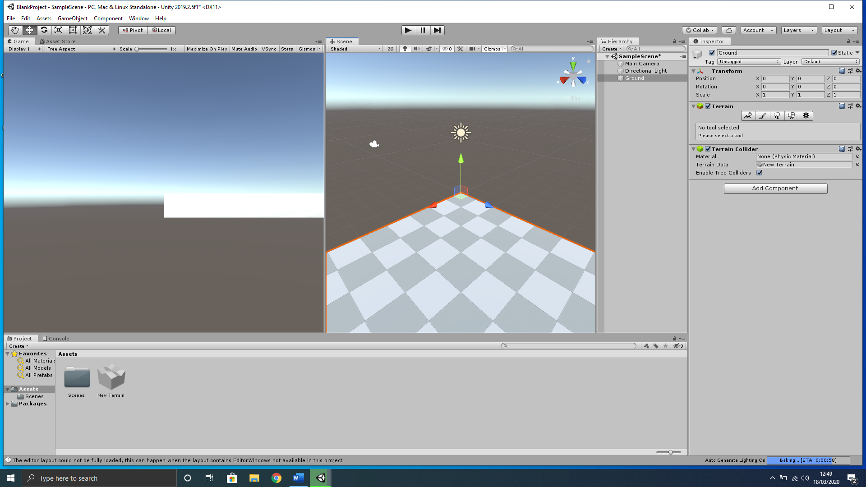
4. Scroll down through the new settings that appear until you reach the **Mesh Resolution (On Terrain Data)** section. In **Terrain width**  and **Terrain Length**,change both values to **100** and leave the other sections at the default settings**.**

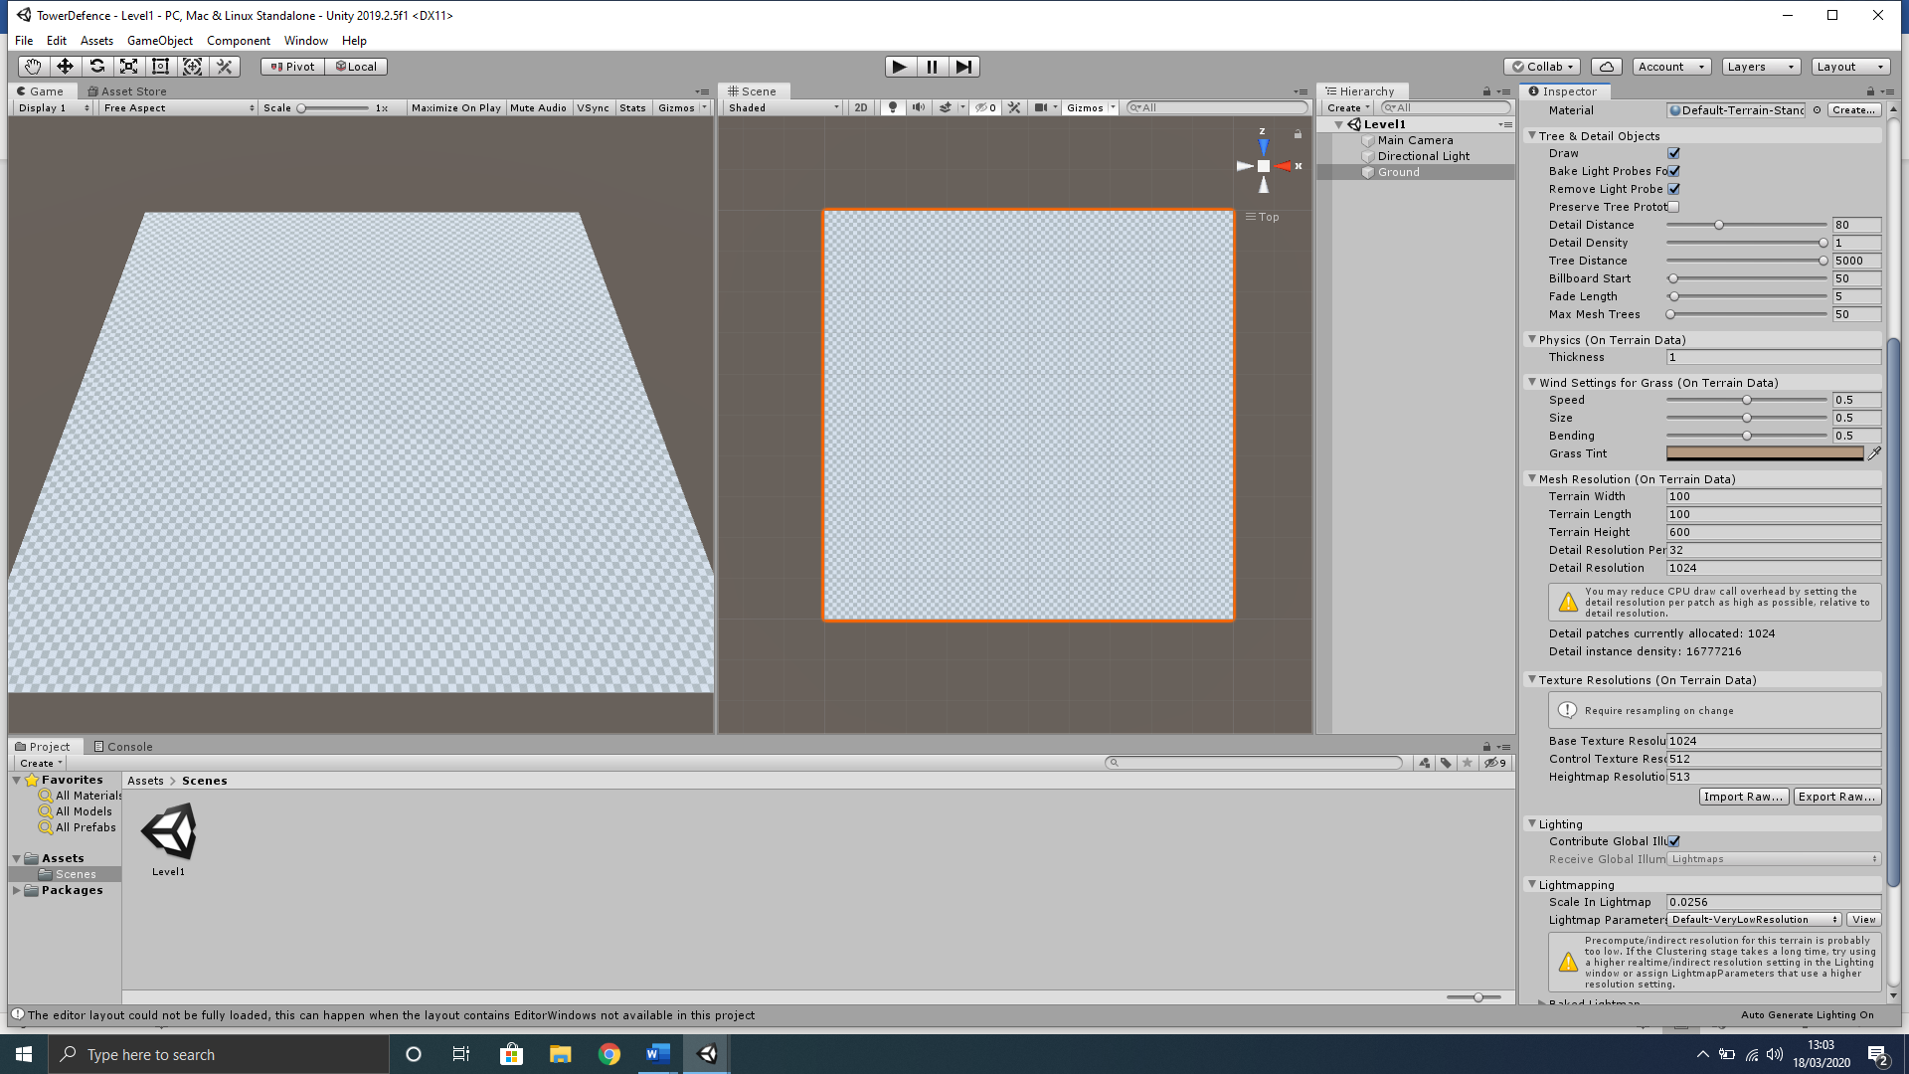

1. At this point you may not have noticed any changes; however, we have changed the terrain size. To help us see the full terrain, better position objects and edit, we should change our **Scene** view to a birds-eye view. This can easily be achieved by using the camera transform component in this **Scene** window. Left-click the **Y** axis (green cone) highlighted below.

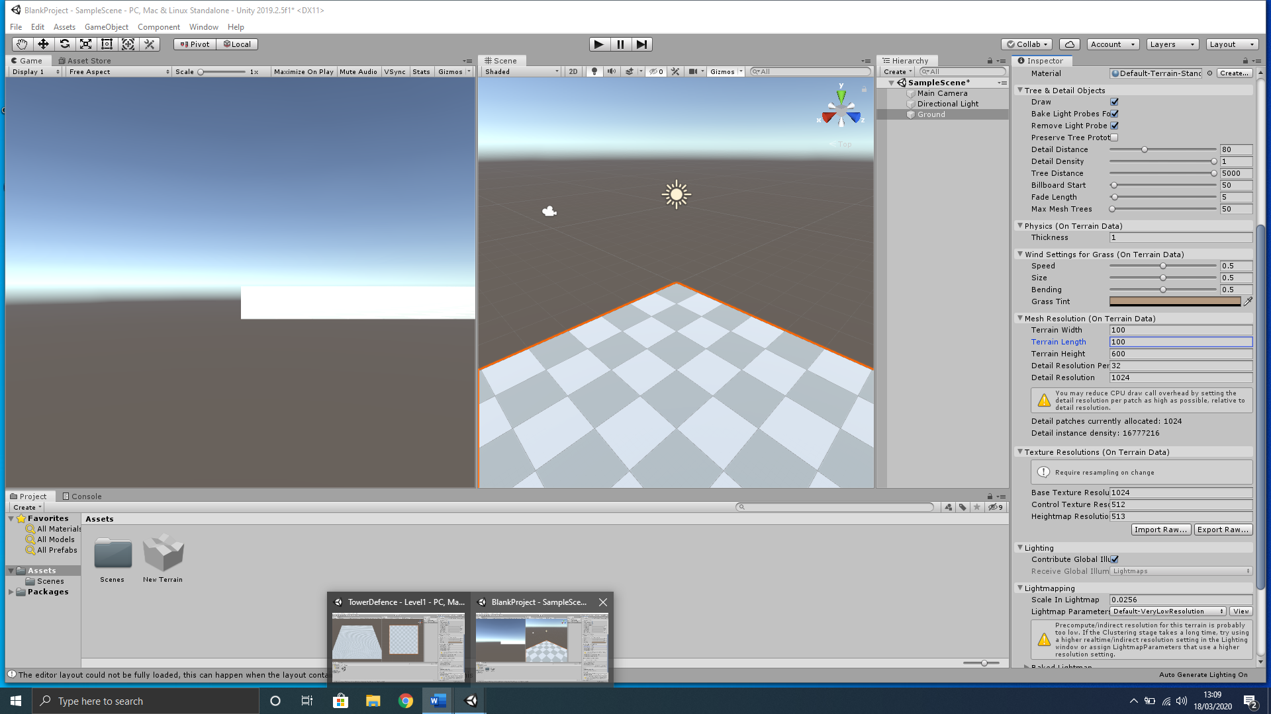

1. You will notice that we still cannot see the full terrain. Use the pan selection (left-click and hold the scroll wheel) and the zoom tool (scroll wheel) within the **Scene** window to position the full terrain within the view like below;

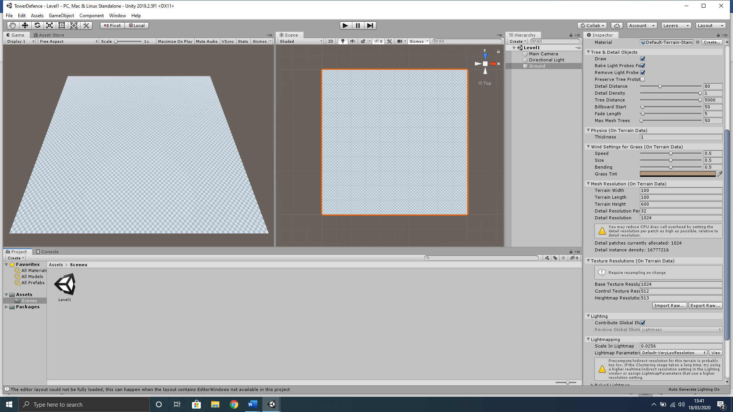

## Static Camera Position

We will set up the default position for the camera to display the game to the user in the **Game** view window.

1. In the **Hierarchy** select the **Main Camera** object.
2. Now with this **Main Camera** object selected in the **Inspector** set the **Transform** component to the settings below;

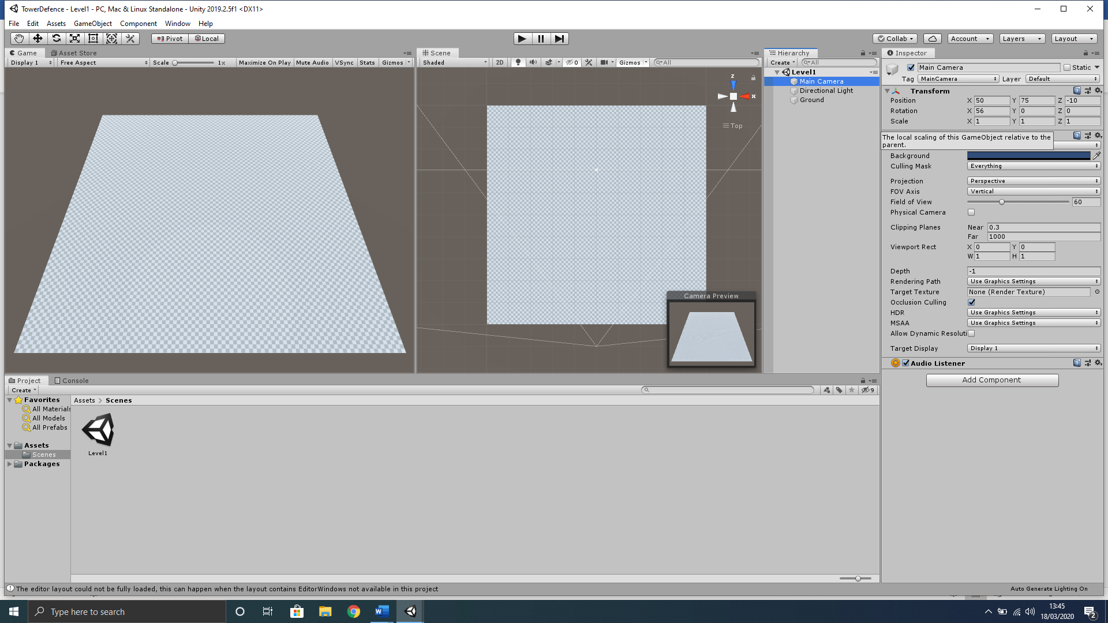

Your scene has now been setup to make it easier to view and edit our game. Remember how you have learned in class that Unity window layouts can be arranged to suit your own workflow, however, we discussed for our development purposes the layout we use to display both the **Game** view window and **Scene** view window side by side, with your **Hierarchy** window next to your **Inspector** window to better connect components. Your overall Unity scene layout should look like below;



# Creating the Path

We will create a basic path for our enemies to follow with a Start and End location. This path will also be laid out with waypoints for the enemy to reach sequentially. We also create a script to accept these waypoints regardless of the amount, however, it is advised at this early stage to keep the waypoint count low and design a simple path until we have our functionality fully tested and working.

## Start Location

Here we will create a simple 3D cube to represent the start location for the enemy troops as a basic prototype object, this can be later to make a more graphically fitting object like a building, automobile or dropship.

1. With nothing selected in the **Hierarchy** window, right-click in an empty space and select **3D Object>Cube** from the context menu that appears.
2. Rename this cube in the **Inspector** to **Start**.
3. Reset the **Transform** component by right-clicking on the word “Transform” and select Reset from the context menu that appears.
4. We will now position the **Start** object up in the top left of our **Ground** object and increase the size slightly using the **Start** objects Transform component. Set it like below;

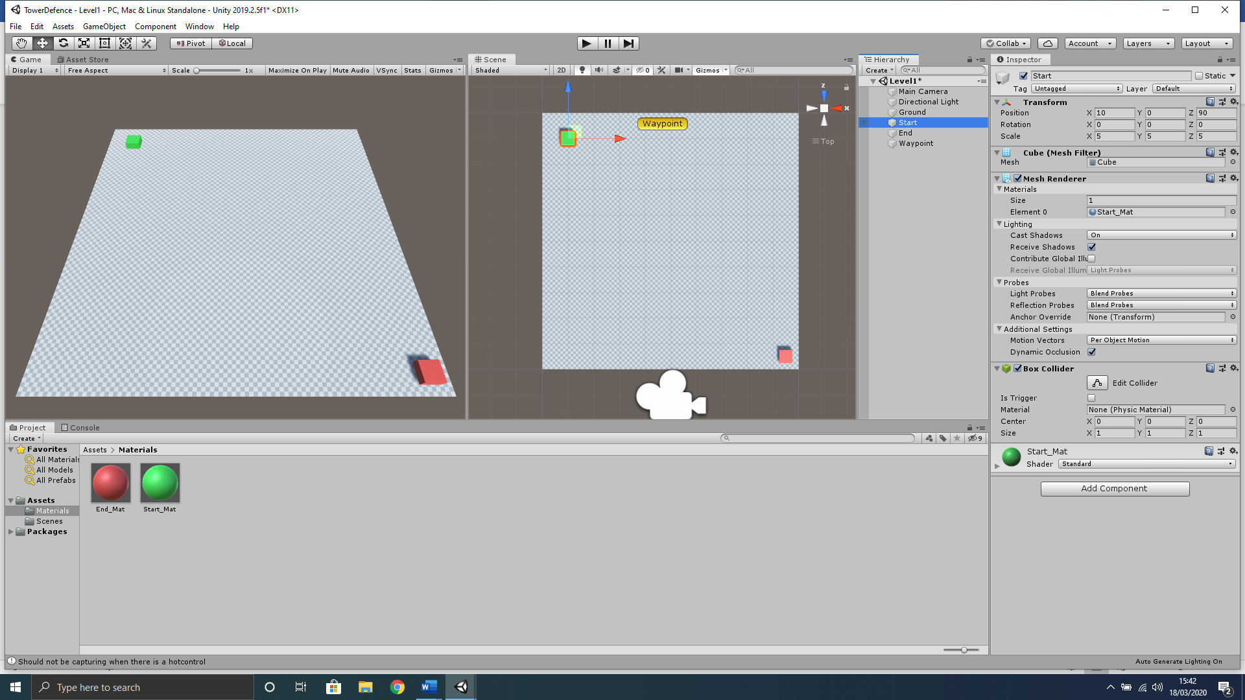

## End Location

1. With nothing selected in the **Hierarchy** window, right-click in an empty space and select **3D Object>Cube** from the context menu that appears.
2. Rename this cube in the **Inspector** to **End**.
3. Reset the **Transform** component by right-clicking on the word “Transform” and select Reset from the context menu that appears.
4. We will now position the **End** object up in the top left of our **Ground** object and increase the size slightly using the **End** objects Transform component. Set it like below;

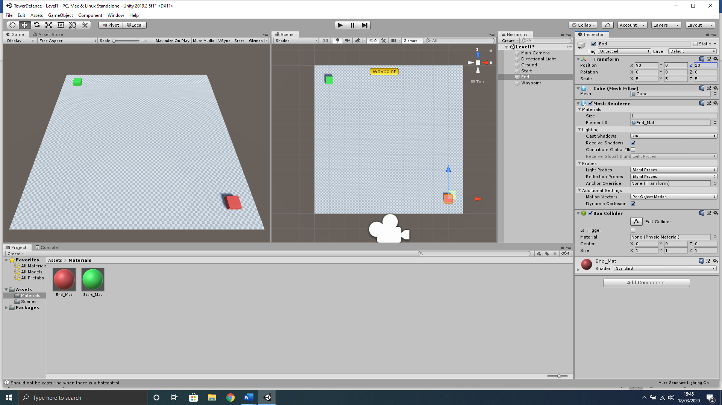

## Creating Start/End Materials

You will notice it is quite hard to distinguish the **Start** and **End** cube from the **Ground** terrain object, therefore, we will create a material for both the **Start** and **End** cube.

1. With nothing selected in the **Project** window, make sure you are in your **Assets** folder and right-click in an empty space and select **Create>Folder** from the context menu that appears.
2. Rename this folder to **Materials** and open this folder in the **Project** window.
3. Now with nothing selected right-click in an empty space and select **Create>Material** from the context menu that appears.
4. Rename this **Material** to **Start_Mat.**
5. With Start_Mat still selected go to the Inspector and under Main Maps section select the colour picker tool next to Albedo component and change to a bright Green colour like below;

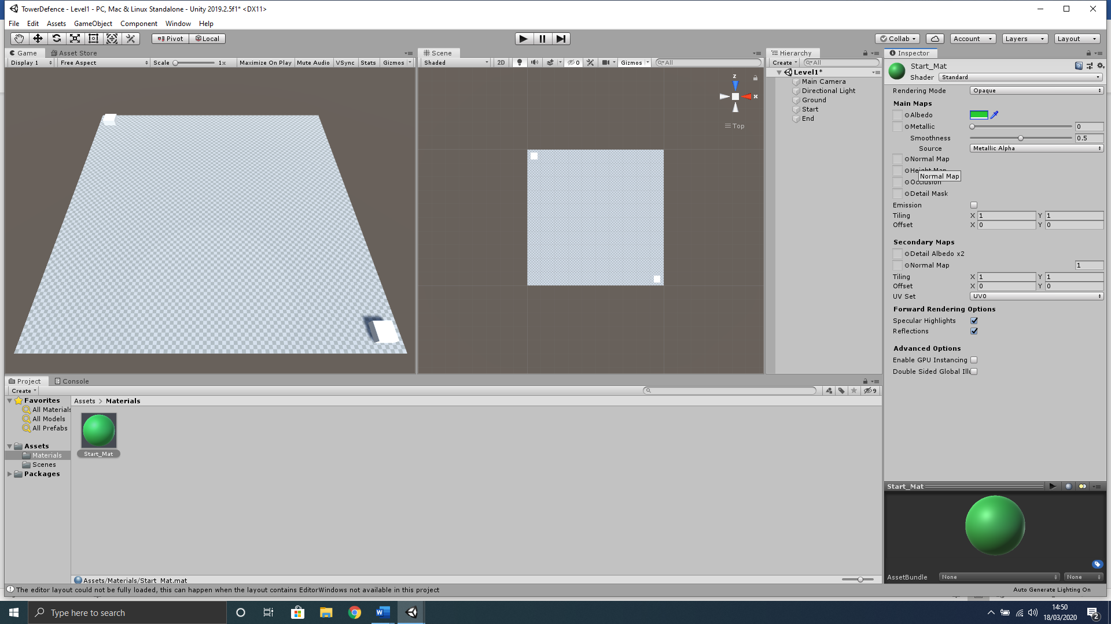

1. In the **Project** window make sure you are in **Assets>Materials** folder and left-click the **Start_Mat** material once to select and use keyboard shortcut **CTRL+D** to duplicate the material.
2. Rename this duplicated material to **End_Mat** and change the **Albedo** colour to **Red**.

## Assigning Start/End Materials

Now that we have created the materials for both the Start and End objects we must assign them to each corresponding object.

1. From the Project window left-click, hold and drag the **Start_Mat** onto the **Start** object in the **Hierarchy** window.
2. Again, from the Project window left-click, hold and drag the **End_Mat** onto the **End** object in the **Hierarchy** window.

## Creating a Waypoint

We will now create waypoints for the enemy objects to follow. These waypoints will be used by a script later as targets for each enemy object to travel to. As mentioned earlier we want to keep it simple for development with not too many waypoints.

1. With nothing selected in the **Hierarchy** window, use the keyboard shortcut **CTRL+Shift+N** to create a new empty object.
2. Rename this object to **Waypoint**.
3. Reset the **Transform.**
4. Now in the **Inspector** window to the left of where the objects name is, there is a dropdown menu we can use to change the display icon for the object;

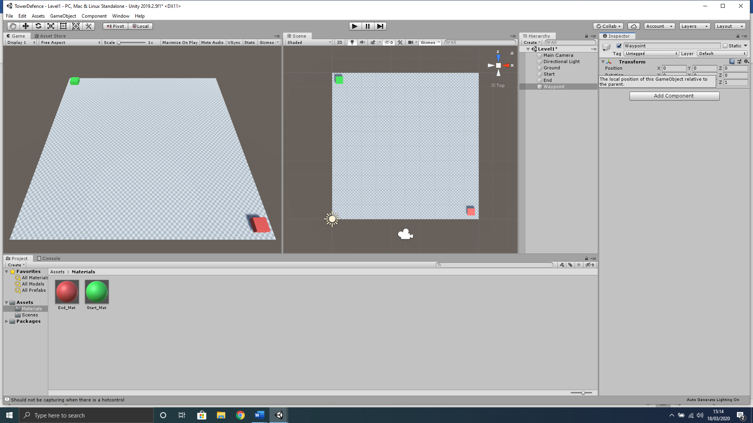

1. Change this to the **Yellow** Capsule icon;

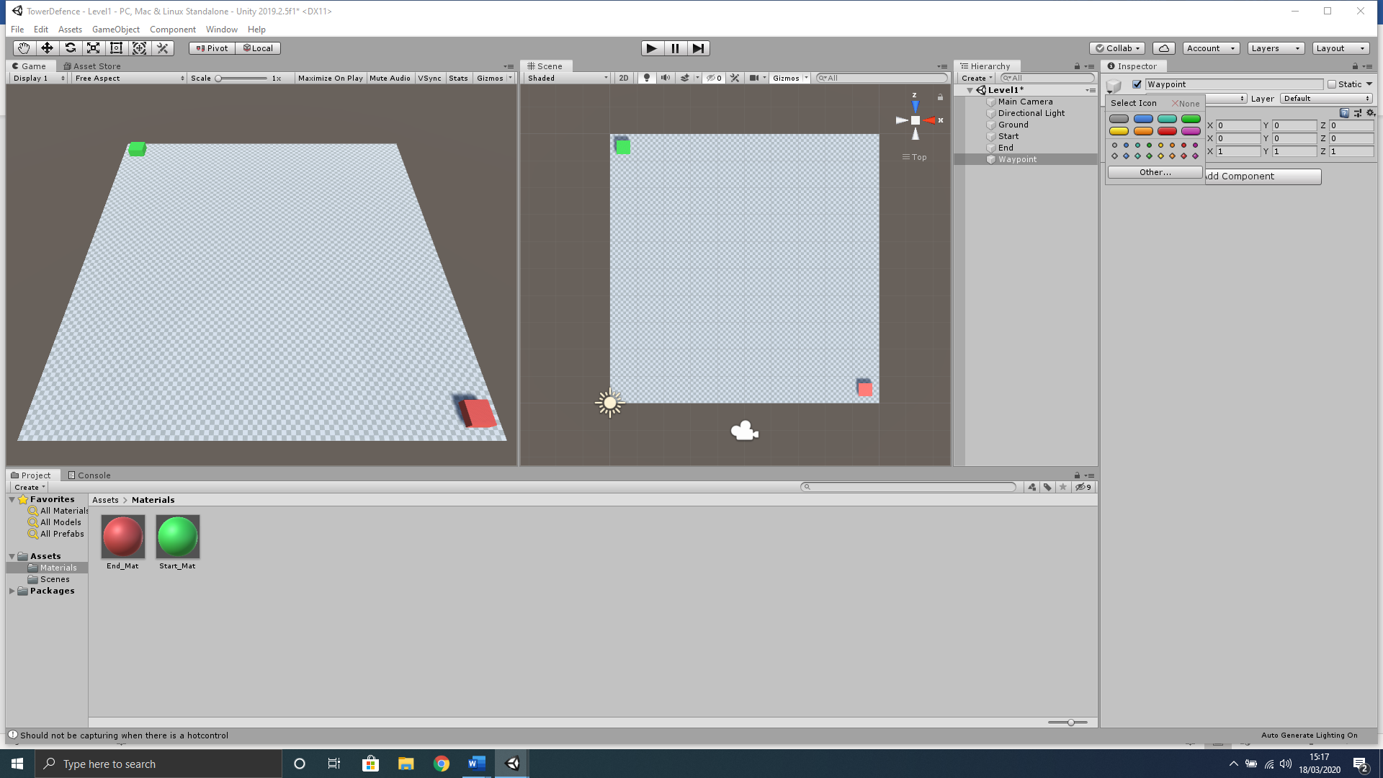

1. You may not be able to see this yet as the Icon size may still be set rather low. We can simply change this by clicking the Gizmos tab in the Scene window toolbar;
2. 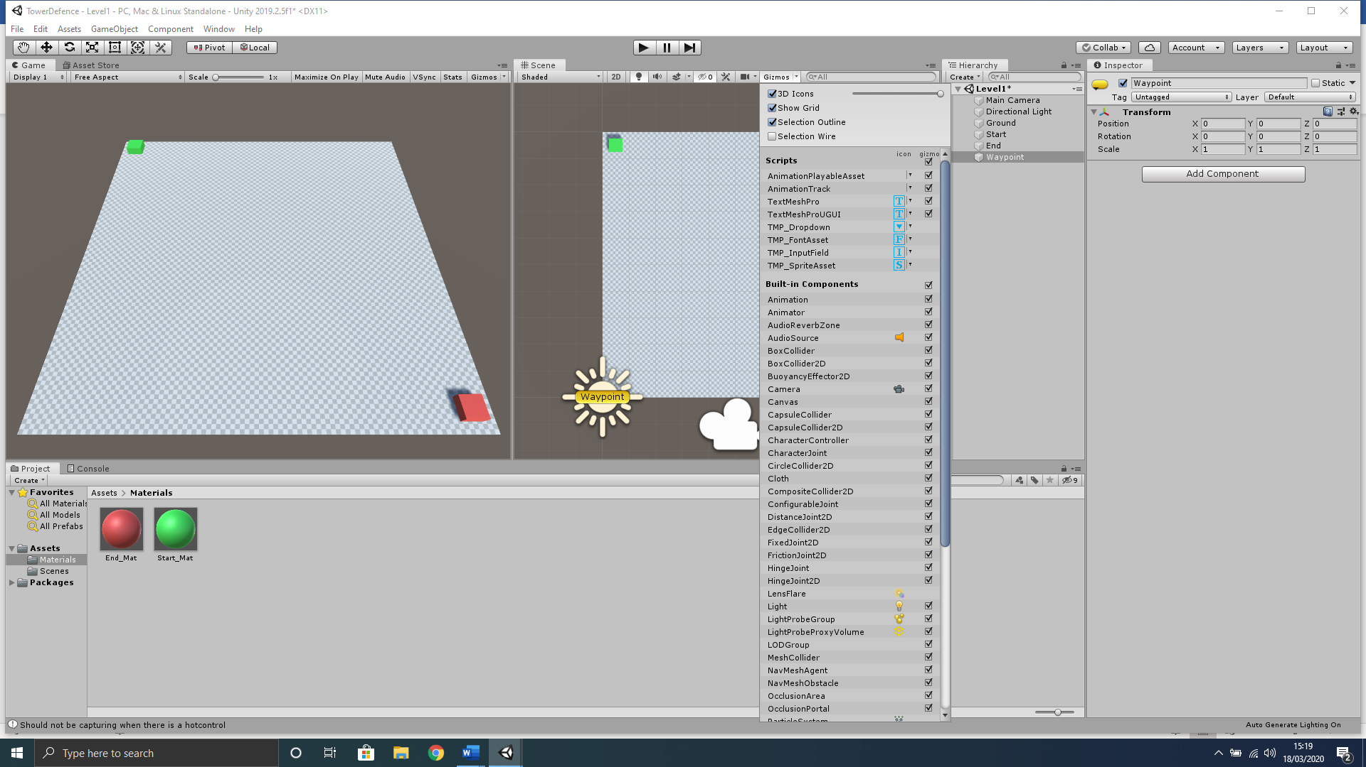
3. At the top of the context menu that appears, change the 3D Icons slider to maximum position;



You will notice all of the Icons within the Scene window have now been enlarged helping us see the waypoint icon better, however, the directional light icon is now in the way of selecting this object as its X/Y coordinates are similar. We can simply move this out of the way to save future issues.

1. In the **Hierarchy** window select the **Directional Light** object and change the Transform component like below to move it out of our way; 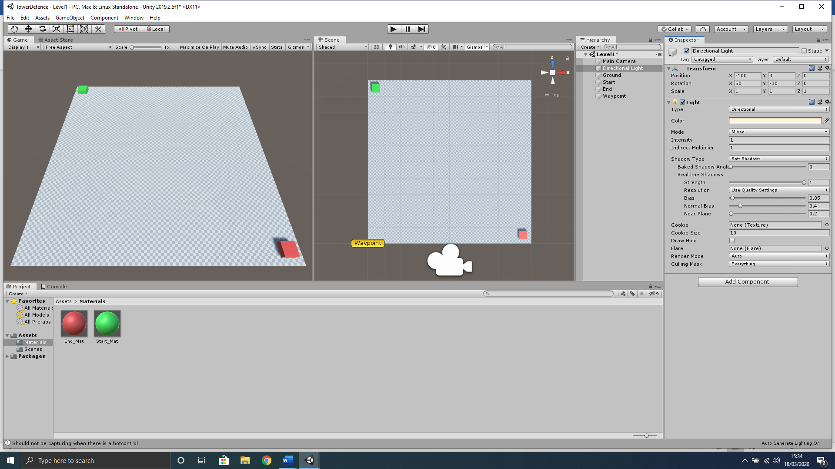
2. We can also position our newly created waypoint to the next location we would like our enemies to travel to from the start locaion. You can set this how you like, however, remember the enemy will travel in a straight line to this waypoint, so try not to make it overly complex to begin with and keep it rather close to your Start object;

## Duplicating Waypoints

Now that we have created and set up one waypoint it makes sense to simply duplicate this rather than setting all other waypoints individually. At this point in development we want to keep it simple so I would recommend no more that 6 waypoints in total with the end waypoint situated directly over the End object.

1. With the Waypoint object selected in the Hierarchy window, press the keyboard shortcut **CTRL+D** 5 times in a row to create your remaining 5 waypoints. (You will notice Unity automatically names these duplicated waypoints as Waypoint(1), Waypoint(2)… etc.)
2. Now position these waypoints sequentially creating an invisible path to the End object, with the End object containing the last waypoint object, like below;

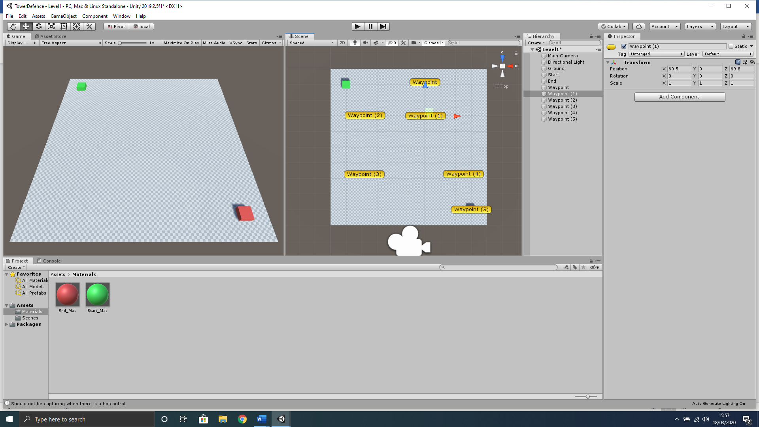

# Designing the Terrain

We can use the toolbar of the terrain object to raise lower and shape the Ground object. Using different brushes and textures design a simple ground for our terrain. The main ground can use the **brushes** to make hill/mountains and final path is created using the **Set Height** tool set to 1. Attempt to create a **Ground** object like below; 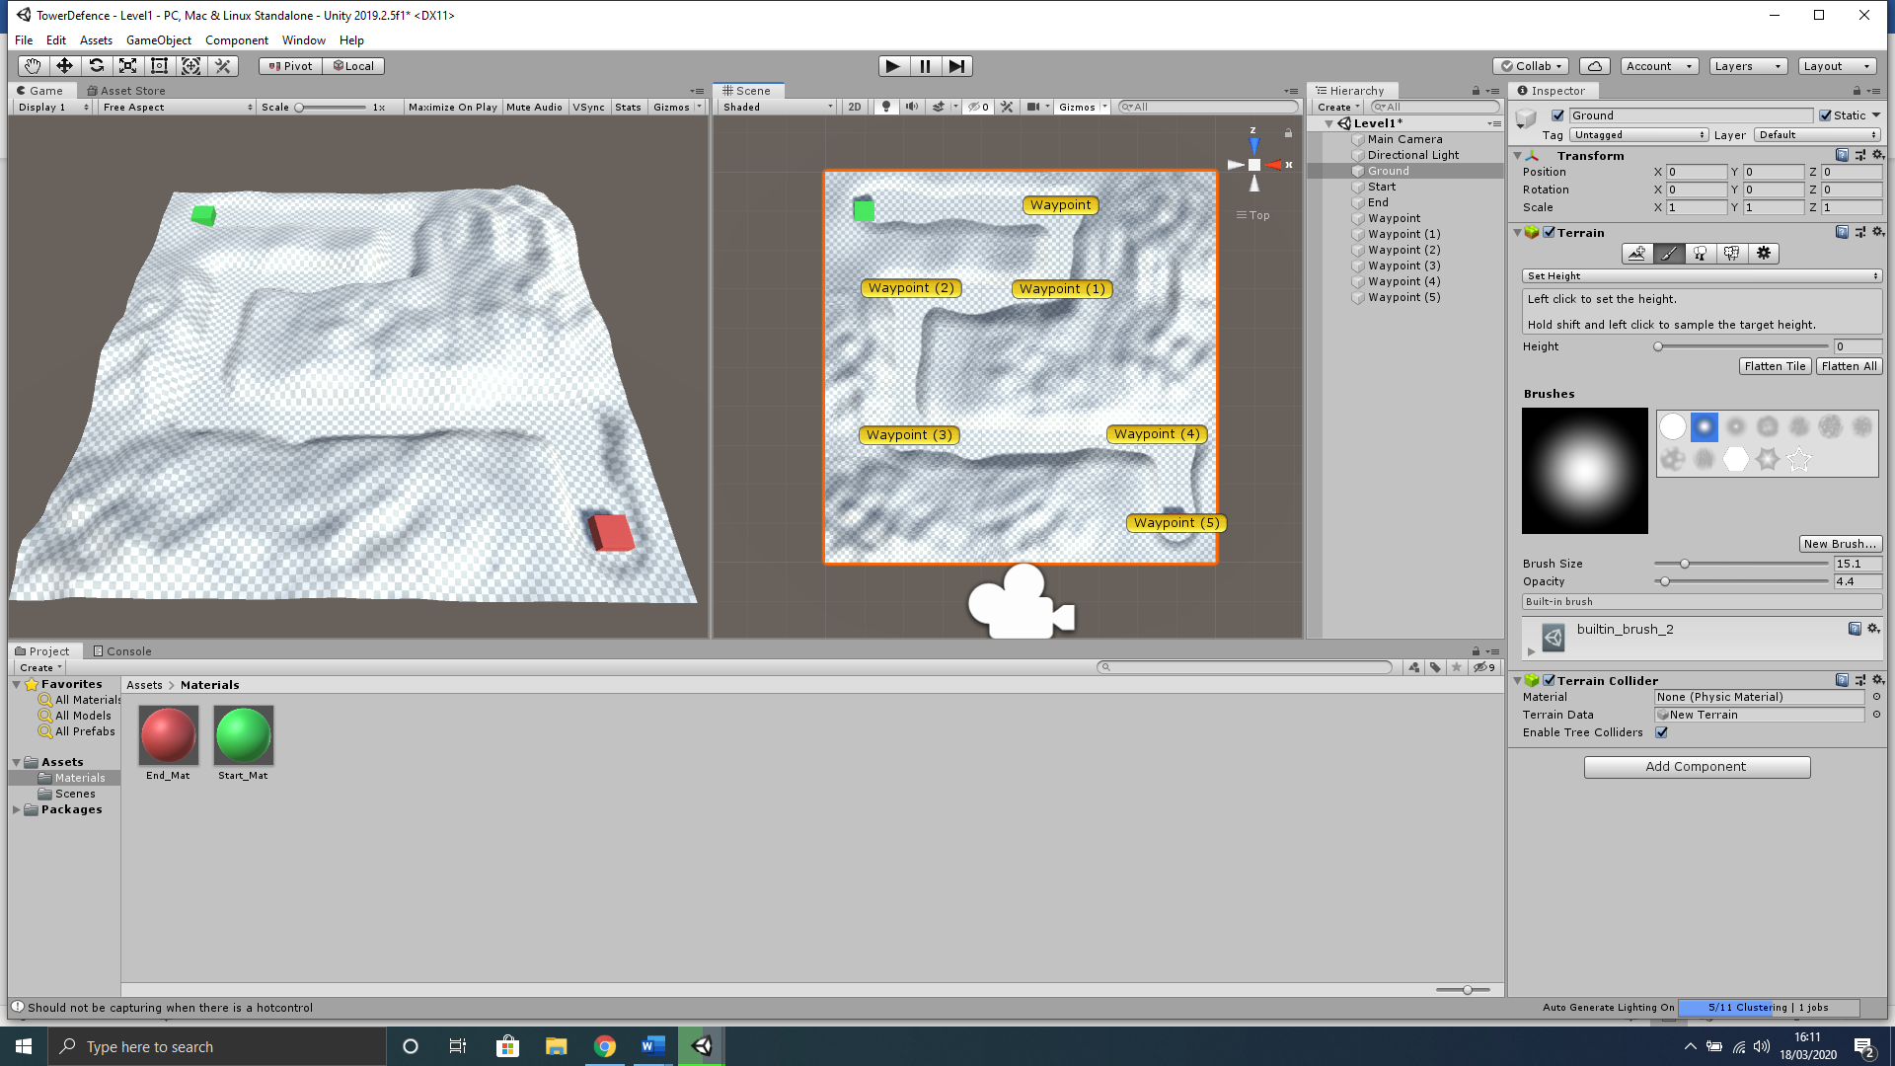

You will notice I haven’t really put much into the design at this point however you can by adding ground textures. As this is not a design class I will not show too much in the way of design and would recommend that you investigate how to use the new terrain tool for yourselves by Googling/Youtube Unity new terrain. (Note there has been a new terrain tool since 2018.3 and youtuber Sykoo has a nice tutorial that can help you get to grips with each part LINK = <https://www.youtube.com/watch?v=2Vvwjfp-hg8>) DO NOT ADD TREES OR ANY OTHER 3D OBJECTS FOR NOW.

# Waypoints Script

Now that we have our individual waypoints created we are going to create an empty object to contain all waypoints, which we can then attach a script to, giving us the ability to easily access and manipulate them using a static reference, as this will be able to be accessed from any other script.

1. With nothing selected in the **Hierarchy**, use the keyboard shortcut **Ctrl+Shift+N** to create a new empty object.
2. Rename this object **Waypoints**.
3. Now in the **Inspector, r**ight-click on the word **Transform** and then select **Reset.**
4. Now select all your waypoints in the **Heirarchy** and **left-click, hold and drag** them onto the **Waypoints** object as children.
5. In the **Hierarchy** left click the **Waypoints** object and, in the Inspector, left click the **Add Component** button.
6. In the search box that appears type the name **WaypointsScript,** then left click the **New Script** option below that is highlighted in blue.
7. Double check you have named the script properly, then left-click the **Create and Add** button.
8. Now in the **Project** window select the **Assets** folder and double left-click the **WaypointsScript** to open in Visual Studio.
9. Amend your **WaypointsScript** to contain the code below;
10. using UnityEngine;
11. public class Waypoints : MonoBehaviour
12. {
13. // Create a public static array of waypoints that can be accessed anywhere
14. public static Transform[] points;
15. // Awake is called before the first frame update
16. void Awake()
17. {
18. // create array for all objects within the Waypoints object
19. points = new Transform[transform.childCount];
20. // iterate through the array
21. for (int i = 0; i < points.Length; i++)
22. {
23. // set each object found to the current location in the array
24. points[i] = transform.GetChild(i);
25. }
26. }
27. }

# Creating the Enemy

1. With nothing selected in the **Hierarchy** window, right-click in an empty space and select **3D Object>Sphere** from the context menu that appears.
2. Rename this sphere in the **Inspector** to **Enemy**.
3. In the **Inspector, r**ight-click on the word **Transform** and then select **Reset.**
4. Press the **W** key on the keyboard to enable the object transform tool.
5. In the **Inspector** set the **Enemy** object **Transform** component to the same **Transform>Position X** and **Z** of the **Start** object, and then set **Transform>Position Y** of the Enemy object height to **1.8.**
6. Also, within the **Transform** component of the **Enemy** object, set the **Scale** in **X, Y** and **Z**  to **2.**

## Enemy Material

We will now create a new material named **Enemy_Mat** and set the **Albedo** colour to a **Light Blue,** then add it to our newly created **Enemy** object. (By now you should be able to create and apply a material to an object without complete guidance).

## Enemy Script

We will now create a script and add it to the enemy that will guide them through the waypoint path.

1. In the **Hierarchy** left click the **Enemy** object and, in the Inspector, left click the **Add Component** button.
2. In the search box that appears type the name **EnemyScript,** then left click the **New Script** option below that is highlighted in blue.
3. Double check you have named the script properly, then left-click the **Create and Add** button.
4. Now in the **Project** window select the **Assets** folder and double left-click the **EnemyScript** to open in Visual Studio.
5. Amend your **EnemyScript** to contain the code below;
6. using System.Collections;
7. using System.Collections.Generic;
8. using UnityEngine;
9. public class EnemyScript : MonoBehaviour
10. {
11. // set enemy speed
12. public float speed = 10f;
13. // Create a transform variable for target position
14. private Transform target;
15. // Set waypoint index variable
16. private int waypointIndex = 0;
17. void Start()
18. {
19. // set the target transform to public static Waypoints array
20. target = Waypoints.points[0];
21. }
22. void Update()
23. {
24. // get the direction to target location
25. Vector3 dir = target.position - transform.position;
26. // move to the target location
27. transform.Translate(dir.normalized * speed * Time.deltaTime, Space.World);
28. // When close to next waypoint get next target
29. if(Vector3.Distance(transform.position, target.position) <= 0.2f)
30. {
31. GetNextWaypoint();
32. }
33. }
34. void GetNextWaypoint()
35. {
36. if(waypointIndex >= Waypoints.points.Length - 1)
37. {
38. // destroy the gameobject at last waypoint
39. Destroy(gameObject);
40. // wait til game object is deleted before continuing
41. return;
42. }
43. // increment the waypoint index
44. waypointIndex++;
45. // set next target
46. target = Waypoints.points[waypointIndex];
47. }
48. }

## Create an Enemy Prefab

1. In your **Project** window, right-click on the **Assets** folder and select **Create>Folder** and name it **Prefabs.**
2. In **Hierarchy** window left-click, hold and drag the **Enemy** object down to the newly created **Prefabs** folder, to make an enemy prefab.
3. Now save your work and run the project to test.